**Restarting Rules for Pirates CSG**

*Created July 2021, last edited August 2024*

-This is an optional ruleset designed to improve upon the original game. There is a list at the end of the document explaining the changes made from the original standard rules.

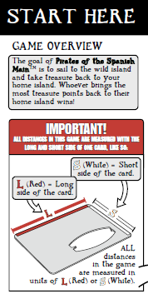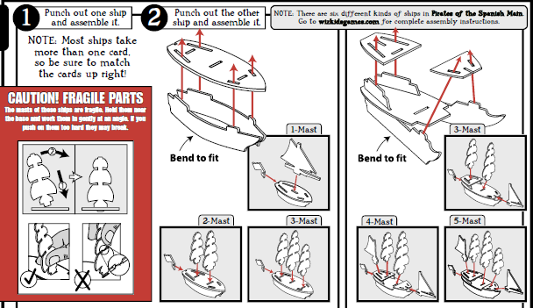

The goal of Pirates CSG is to have the most total points in play when the game ends!

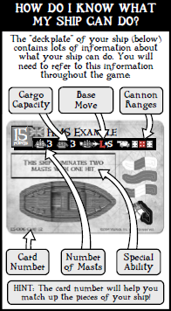

Rules of the High Seas

Here are some game concepts important to the Pirates CSG rules:

• Six-sided dice are abbreviated “d6.”

• Ability text (found on the fronts of cards) overrules these rules; that is, abilities are meant to be exceptions to these rules. The only rule that is never overruled is that a cannon die roll result of 1 always misses.

• Flavor text (fiction/lore found on the cards) has no bearing on game play; it is there merely to tell part of the game's story. Reference a card's ability text to see what it can do in the game.

• No Stacking Rule: Two sources of the same ability text on a ship (such as from the ship and a crew, or from one crew and another crew) are not cumulative; that is, you can use that ability on that ship only once each turn.

• The bow of a ship is a zone at the front of the ship. It begins where the front of the ship actually touches the table and extends forward (including any masts, mastheads, etc.).

• Two Action Limit: You can't give a ship (or other game pieces that can be given actions, such as sea creatures) more than two non-free actions each turn.

• You may measure anything at any time, as long as it does not significantly delay the game.

• Play with good sportsmanship and have fun!

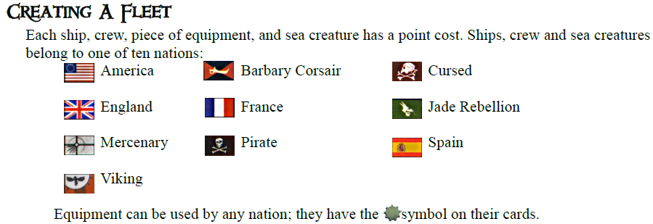

Fleets

To create a fleet, determine the build total at which you will play your game. A standard game uses a 60 point build total; that is, choose ships, crew, equipment, events, and sea creatures with a combined point cost up to 60 points. Any build total can be chosen as long as all fleets use the same total. If a ship comes with a flag, she must fly it from her stern (rear of the ship). Players can build mixed-nationality fleets. The number of treasures and the total value contributed by each player should be decided before constructing fleets, if possible. The identities and complete statistics *(including abilities)* of all ships and forts in play are considered open information and must remain accessible to all other players during the course of the game. Events should not be used unless all players agree to allow them.

-Creating your fleet occurs before the setup phase of a game. This is significant for the timing of certain abilities.

**The No-Duplicates Rule:** A player cannot have two or more of the same character, ship, sea creature, event token, or fort in their fleet at the same time unless it is captured from an opposing player. Generic crew and equipment are not limited in this way.

Setup

The game can be played on any tabletop or other flat surface. Each player rolls a d6 (reroll ties). The player who rolls the highest result is the first player; the player to the left of the first player is the second player. The order of remaining players is determined by continuing left around the playing area. The standard game uses Round Earth rules.

Round Earth: Any game piece that moves over an edge is immediately placed on the opposite edge of the playing area at the same heading and may continue with any remaining movement segments. Game pieces must be on the same side of the map to shoot at each other or use any range-based abilities and effects. If a ship ends its movement or move action on the edge of the map, more than 50% of its hull must be over the edge in order to place it at the other side.

Alternative options include but are not limited to:

-The maximum extents of the playing area (as designated by the edge of a table and/or a clearly marked perimeter) are considered an impassable wall that prevents all movement beyond.

-Flat Earth: Any game piece that moves over the edge is permanently removed from the game. Players cannot voluntarily move their ships over the edge.

If players desire to use something other than Round Earth, they should propose that before fleets are built and receive agreement from the other players.

Placing Islands

For a 60-point game, players can use three islands per player (ex: six islands for two players, nine islands for three players, etc.). If you don't have enough islands, use similarly sized and shaped objects to represent them. Starting with the first player, players take turns randomly choosing an island from the pool of contributed islands and placing it on the play area. Islands must be placed at least 2L but not more than 6L from each other.

**Mysterious Islands.** Mysterious islands are special islands that have a palm tree symbol on them. They are placed as regular islands and have game text on them that might have special effects during the game. You can also choose to play them as regular islands with no special effects. Mysterious islands are always placed so that the symbol is face up; they are flipped over when a ship first docks at them.

Placing Terrain

Terrain is printed on the backs of islands. Using terrain is optional. If you use terrain, players should agree on the number and type of terrain pieces that will be used; we recommend that players each place the same number of terrain pieces, in the same order that they placed islands. Terrain can be placed anywhere on the play area, and each piece can touch any other piece of terrain or islands as long as they are not directly on top of each other. See “Terrain” for details.

Choosing Home Islands

The last player chooses their home island first, and that player places their ships so that their bows touch that island. The second to last player then chooses their home island and places their ships, and so on until the first player is the last to choose their home island. Ships cannot be placed in contact with terrain during setup. The remaining islands are called wild islands.

-Mysterious islands chosen as home islands function as non-mysterious islands. They are not flipped over to reveal their special effects when ships dock at them (see “Docking”).

Placing Crew and equipment

If you have chosen crew and/or equipment, put them face down either on your home island or on the deckplate card of the ship to which you assign them. Each crew/equipment takes up one cargo space on a ship. No matter what a ship's cargo capacity, it can't carry crew and equipment with a combined point cost more than the ship's point cost. If a crew and ship are not of the same nationality, that crew can't use its ability while on that ship. A crew with a point cost of 0 can be assigned only to a ship that shares its nationality. You must reveal (turn face up) a crew when using its ability, and it must remain face up for the remainder of the game. Crew and equipment can use their abilities only on ships, never on islands. Crew and equipment left on wild islands can be loaded by any ship.

Link symbol (black) - card size**Linked crew and ships.** Some crew are “linked” to other crew and ships (as noted by the symbol printed on their cards). When two linked crew are assigned to the same ship, they share a single cargo space. In the same way, if one crew is assigned to a ship to which it is linked, that crew does not take up cargo space. If multiple links are present on a ship, all crew that link share the same single cargo space. Links are considered rules rather than abilities, so they are not subject to the No-Stacking Rule, and they cannot be cancelled or copied.

Placing Treasure

Each treasure coin is printed with a number indicating how much gold it is worth. For a 60-point game, each player should contribute 8 coins of any value or type. If using the Points in Play win condition (see Winning the Game), each player should contribute 8 coins worth gold equal to their build total (ex: 60 gold in a 60 point game) - this can be accomplished by multiplying each regular coin’s value by 4. (to achieve 8 for 60 instead of the original standard of 8 for 15)

For non-standard games, players should simply contribute an equal amount of coins of any value or type. Shuffle the treasure with the numbers face down, and then randomly distribute an equal number of coins to each wild island.

**Unique treasure.** Some treasure is unique. A player can't contribute more than one unique treasure with the same name to the total treasure contributed to the game. At the beginning of the game, each unique treasure is worth 0 gold. A unique treasure's value may change later in the game, depending on its ability text. Players can insert unique treasure into the treasure that is randomly sorted and placed on wild islands.

Playing the Game

Actions

The first player takes the first turn and is able to give one of four actions (move, shoot, explore, or repair) to each of his or her ships (or other game pieces that can be given actions, such as sea creatures). You can give actions only to game pieces in your fleet.

**Free action.** Unless a game effect specifically requires one of the four actions, that effect is a free action. Free actions happen automatically and immediately. A free action does not count as a ship's action for the turn on which it occurs.

**Multiple actions.** Some game effects allow you to give a ship a second action during a turn. You can't give a ship (or other game pieces that can be given actions, such as sea creatures) more than two non-free actions each turn. If an ability allows a ship to be given an additional full action, that action does not have to be given to the ship immediately after completing its standard action for the turn; actions may be given to other game pieces in between.

Each turn you can choose ONE of the following actions for EACH of your ships. *(unless an ability says otherwise)*

Move Action

Each ship can move a certain distance based on its base move (shown on the ship’s deckplate card) and any bonuses.

1. Place one end of the appropriate movement bar (S or L) at the forward-most point (the bow) where the ship’s hull touches the playing surface, or at its baseplate. Most ships have two distinct points that qualify so either may be chosen, but once chosen that point must be used for that entire move action; you cannot switch reference points from one segment to the next.

2. Rotate the opposite end of the movement bar to the desired heading.

3. Once the heading is chosen, pick up the ship and place it at the end of the movement bar with its bow pointing in the direction of the movement. Use the location on the bow that movement was measured from as the reference point when placing the ship at the end of the movement bar.

--You are not required to use the full length of the movement bar; the ship may be placed at any location along the length of the bar.

--If the ship cannot be placed at the desired point on the movement bar because an impassable object is in the way, you must choose a different heading or you must move the ship a shorter distance so that it would make contact with or stop short of that object.

4. After placing the ship, if it has not made contact with another object, repeat the above steps for any remaining movement segments that are available to the ship.

--You are not required to use all available movement segments.

A ship can't move through any island or another ship. If a ship has a combination move, such as L+S, you can choose to move her either L or S first, though she can change direction only between each measurement. If a ship touches another ship or an island during her movement, she must stop, even if she could move farther that turn.

**Derelict.** A ship is derelict if she has no masts. A derelict can't move and can be given only explore actions or repair actions. A derelict can still carry treasure and crew. Some abilities will prevent a ship from being considered derelict even if it has no masts remaining.

The following game functions can be performed using a move action or as the result of a move action.

**Docking**

As a free action, a ship docked at (touching) an island or a fort can drop off and board crew or equipment, or transfer crew or equipment to and from another ship docked at the same island. You can't dock at an opponent's home island or at an enemy fort.

**Unloading treasure.** When you dock at your home island, you must unload all treasure worth gold points; this is a free action. Treasure unloaded at a fort is placed inside of the fort, and it counts toward victory. See “Winning the Game.” You cannot load treasure from any home island, even your own, unless a rule or ability specifically allows it.

**Mysterious islands.** When you dock at a mysterious island, before any other action is taken (including any free explore action), roll a d6 for special effects as indicated by the table on the island. The rolled effect occurs immediately unless specified otherwise; for example, “The next time this ship explores this island . . . .” Mysterious island effects are determined each time a ship docks there, so a ship might have different experiences on the same island. If you can't fulfill a mysterious island effect, ignore it. If you dock at a mysterious island with no special effects showing, immediately flip it over to reveal the effects and proceed as described above. The island remains flipped over for the rest of the game.

**Ram**

After a ship resolves a move action, if any part of her bow physically touches any part of an enemy ship, she rams that ship. Roll a d6; if the result is higher than the number of masts remaining on the enemy ship, the enemy ship's player must choose and eliminate one mast from that ship. Unless the enemy ship becomes derelict from being rammed, the ramming ship automatically becomes pinned. Ships can't ram each other while they are pinned.

Pin. Unless an ability states otherwise, a ship becomes pinned only after ramming another ship. A ship is pinned when her bow is in contact with any part of an enemy ship. The pinned ship can't move until the other ship moves away or has no masts remaining.

**Board**

After a ship rams another ship, either player can initiate one (and only one) boarding party as a free action; the player whose turn it is decides first. Each player rolls a d6 and adds the result to the number of masts remaining on his or her ship. The player with the highest total can choose whether to eliminate one crew or equipment on the other ship, OR take one treasure or equipment from the other ship. The loser of the boarding party chooses which crew to eliminate, while the winner chooses which treasure/equipment to take after looking at the ship’s treasure and equipment.

**Tow**

If a ship can be given a move action and any part of her is physically touching the bow of any derelict, she can tow that derelict as a free action. As a free action, move the derelict so that her bow touches the stern of the towing ship. The towed ship and any crew or treasure on that ship become part of the towing player's fleet. The base move of the towing ship becomes **S**; the towed ship moves with the towing ship as a free action. When the towing ship docks, you may dock the towed ship at the same island or fort as a free action.

Shoot Action

The number on each of your masts is its cannon rank. When you attack, you must roll HIGHER than this number to hit. The color of the square is the range: white for S (short range), red for L (long range). A shoot action allows you to fire ALL of that ship’s cannons that are in range of any targets.

Measure an invisible “line of fire” from the printed die on the mast to any part of the target. If this line crosses one of your own ship's masts or sails, an island, or ships other than the target the line is being drawn to, the shot can't be made. If you’re within range, you can shoot that cannon. Before rolling, declare which cannon is shooting at which target. Roll the die once for each cannon in range, and compare each result to the rank of that cannon. If you roll higher, you hit. If you roll lower or the same, you miss.

When you hit an enemy ship, your opponent has to remove one mast, but he or she gets to choose which one. When a mast is removed, that cannon can no longer fire.

-You cannot shoot at ships docked at their home islands.

-You cannot shoot at a ship in your own fleet.

-A die roll result of 1 automatically misses, regardless of any cannon bonuses that may be available.

**Sinking a ship.** If a ship with no masts is hit, she sinks. When a ship sinks, remove her and any crew, equipment, and treasure on her from the game. Unique treasure is removed from the game when it sinks.

**Scuttling.** You may want to sink your own ship rather than have her fall to your opponent. At any time during your turn, you can give one of your derelict ships a free action and declare that you plan to scuttle that ship. Roll a d6. On a result of 5 or 6, that derelict ship sinks at the beginning of your next turn. If an opponent begins to tow that ship before the beginning of your next turn, the scuttle attempt fails. All crew, equipment, and treasure on a scuttled ship are eliminated when she sinks.

Explore Action

If a ship is docked at a wild island, you can give her an explore action to look at all the treasure on that island (without revealing it to the other players) and choose as much treasure as you want to take (within the ship's cargo capacity limits). Each treasure coin takes up one cargo space. Place each chosen treasure face down on the ship's deckplate card. Any treasure not taken is left face down on the island. When you leave a wild island, mark that you have explored it by leaving a token (such as a pennant flag) on the island; if you dock at an island with your token on it, you can explore it as a free action after docking. You can also use an explore action on any allied ship or derelict that your ship touches, which allows you to transfer crew, equipment and treasure between ships while at sea. You cannot dock at, explore, or take treasure from opposing home islands unless an ability says otherwise.

A unique treasure does not take up a cargo space unless an ability says otherwise. Unique treasures that are not loaded face down must be taken by the first player to explore the island on which it is placed. Place it face up on the ship's deckplate card; any ability a face-up unique treasure has comes into play immediately (as a free action).

Repair Action

The repair action allows a ship docked at her home island or fort to repair (bring back into play) one mast.

Keywords

A keyword represents an ability a card has. If a card has a keyword, it appears on the front of the card in the ability text box. When playing that card, follow the rules of that keyword in addition to any other ability text the card might have. If a keyword or an ability doesn't specifically say that a game piece can't do something, then it can do it. (For explanations of specific keywords, see the Master Keyword List)

Forts

Forts are assembled like ships. Fort flags represent cannons, and you can customize a fort by placing flags on whichever slots you would like. The number of flags on a fort must match the number of cannons it has when first built. Forts are not placed during setup; rather, they are purchased and built during the game on wild islands you have explored. A wild island may have only one fort on it at a time.

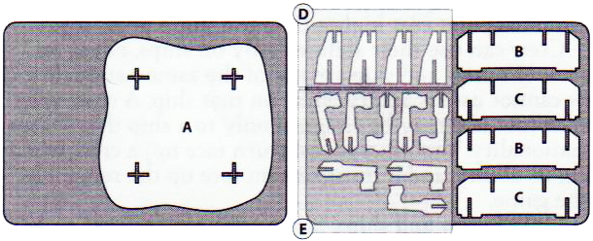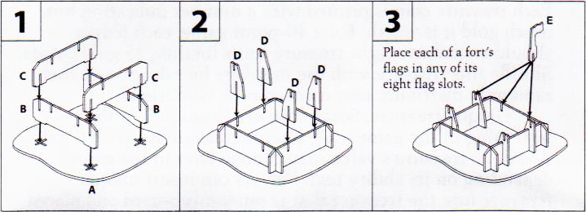

Building Forts

To build a fort, the following three conditions must be met:

-You must have an amount of gold points on your home island equal to or greater than the fort's gold point cost.

-You must have a ship docked at a wild island you have explored in order to build a fort there.

-You must have at least one ship of the same nationality as the fort in your fleet.

If these three prerequisites are met at the end of one of your turns, you may build the fort as a free action. Take the gold used to pay for it from your home island and place it inside of the assembled fort; this gold still counts toward winning the game. Place the assembled fort on any wild island you have explored and at which you have a ship docked. The fort must be placed on the island such that two of its opposite corners are completely on the island. The effects of a mysterious island are ignored if a fort is present on the island.

**Treasure.** If there is any face-down treasure on the island where the fort is built, move that treasure inside of the assembled fort; it is now yours. You may use a ship to load treasure from a fort and move it to another fort or to your home island, but a fort must always have a number of gold points inside of it equal to or greater than its gold point cost.

**Shooting.** Forts may be given shoot actions. Shooting with fort cannons is just like shooting with ship cannons; use the indicated ranges and ranks on the flags and measure distance from the flags. Lines of fire drawn from forts are not blocked by other ships, sea creatures, or islands. When a fort is hit, its player eliminates a flag.

**Repairing.** If a Shipwright is placed on an island with a fort, that fort may be given a repair action to replace one eliminated flag; you may place the flag in any open position.

**Destroying forts.** If a fort with no flags is hit, remove it from the game and place all of the gold that was inside of it back on the island, which reverts to an unexplored wild island.

Terrain

Terrain is printed on the backs of island cards. You may choose to use the terrain side (per the rules for that terrain, below) or the island side (per the normal rules for islands). If any part of a ship touches terrain at the end of any movement segment the effects of that terrain must be applied immediately. If the ship has not become derelict, wrecked, tangled, or “lost”, and has not been placed at another whirlpool, it may then continue with any remaining movement segments. The effect of a given terrain piece is applied only once per move action, regardless of the number of segments that may end on or in contact with it.

Fog Bank

A fog bank has the numbers 1-6 printed around its edge. Fog banks block lines of fire. When any part of a ship or sea creature touches a fog bank, the entire game piece must be placed within the fog bank as a free action; the game piece's turn ends, even if it could move farther that turn. A game piece in a fog bank is lost. Lost game pieces can't shoot, be shot at, ram or be rammed, pin or be pinned, or board or be boarded by other ships. Game pieces exit fog banks in random directions. When a game piece is given a move action to exit a fog bank, roll one d6 before moving it. Place the game piece outside of the fog bank facing away from the fog bank and touching the number on the fog bank that matches the die result; it can face in any direction away from the fog bank and is no longer lost. Begin moving the game piece from that point. If the rolled exit point for a ship is blocked by an island or another ship, place it at the edge of the fog bank as close to the rolled number as possible; do not re-roll. If some other terrain is present, its effects apply normally.

Iceberg

An iceberg has the numbers 1-6 printed around its edge, as well as a number printed at its center. At the beginning of each player's turn, before any actions are assigned, that player must roll a d6. Compare the result to the center number printed on all icebergs in play. If the result matches any iceberg(s), those icebergs move that turn. For iceberg movement, roll another d6 and match the result to the number printed around the iceberg's edge. Measuring straight out from that number away from the iceberg, move the iceberg S. Do not turn or rotate it. If an iceberg touches any ship or sea creature, stop moving it and eliminate one mast or segment from the touched ship or sea creature. If a ship moves or is moved and touches an iceberg it must stop immediately, even if it has additional movement distance and/or movement segments remaining. The ship takes damage normally, as if the iceberg had moved.

Reef

When any part of a ship or sea creature moves onto a reef, roll a d6. The result is the reef's rating until the end of that player's turn. Place the die result on the reef to remind you what the rating is. Compare the rating to how many masts or segments the game piece had when it was constructed. If the reef's rating is lower than this number of masts or segments, the game piece has a number of masts or segments eliminated equal to the difference. For example, if a 3-mast ship sails over a reef with a rating of 4, no masts are eliminated. If a 4-mast ship sails over a reef with a rating of 2, two masts are eliminated. If the reef rating and number of masts or segments are the same, no masts or segments are eliminated. A game piece that begins its turn on a reef does not have to roll to see if masts or segments are eliminated when it moves off of the reef.

**Shipwreck:** If a ship takes more damage than the number of masts remaining as a result of sailing over a reef, she is wrecked and remains on the reef; a wreck blocks movement and lines of fire. To signify that a ship is a wreck, remove one of her hull pieces. This will cause the ship to “lean” onto the reef and look like she is wrecked there. Any crew, equipment and treasure on a wreck remains on the wreck, and wrecks can be explored. Treasure on a wreck at the end of a game does not count toward victory for any player.

A wreck is not considered part of any player’s fleet. Sea creatures that have all their segments eliminated by a reef are eliminated as normal.

Sargasso Sea

When a ship or sea creature moves over a Sargasso Sea, roll a d6. The result is the Sargasso Sea's rating until the end of that player's turn. Compare the rating to how many masts or segments the game piece had when it was constructed. If the Sargasso Sea's rating is higher than the number of masts or segments, the game piece is tangled in the weeds and might not be able to move. For example, if a 3-mast ship sails over a Sargasso Sea with a rating of 4, she is tangled. If a 4- mast ship sails over a Sargasso Sea with a rating of 2, the ship is unaffected. If the Sargasso Sea rating and the number of masts or segments are the same, the game piece is unaffected. If a game piece is tangled, you can use its next move action to try to free it. Roll a d6 and add the current number of masts or segments on the tangled game piece to the result. If the result is more than 6, the game piece is untangled. Orient it in any direction with its stern touching any edge of the Sargasso Sea; it can move normally during its next action.

Trade Current

A trade current is a type of terrain not placed at the beginning of the game. Instead, game effects allow trade currents to be placed during the game. For example, crew with the Navigator keyword can place trade currents. A trade current is friendly to the player who placed it. Once per turn when a friendly ship moves over or begins her turn touching a friendly trade current, she gets +S to her base move. Each ship can gain only a single +S each turn, regardless of the number of different trade currents it touches or the

number of move actions it is given. There is no limit to the number of different ships that can gain the +S bonus from a specific trade current during a single turn.

Whirlpool

When any part of your ship or sea creature touches a whirlpool, you may choose to place it so that it touches any other whirlpool on the play area. If you do, roll a d6 after it is moved. On a result of 1-3, eliminate either one mast or segment, one treasure, one crew, or one equipment from the game piece. The use of a whirlpool’s effect is optional. If it is not used, no die roll is required. In order to “use” a whirlpool, the ship must be placed at a different whirlpool. A ship cannot exit the same whirlpool that it entered simply to dispose of unwanted cargo. Whirlpools only eliminate masts, treasure, crew, and equipment. They cannot sink ships. Using a whirlpool to jump to another whirlpool ends the ship’s entire move action. It cannot shoot (via a Captain), ram, board, or use any other effects that require a move action, until it is given another move action after exiting the second whirlpool.

Winning the Game

The game ends immediately when one of the following conditions has been met:

-All available gold has been unloaded to home islands.

-Only one player is able to give any future move actions to any of their ships.

When any endgame condition is reached, players add up the total gold value of all treasure on their home islands and in their forts. If there are more than two players, the players also add the gold value of treasure on their ships. Treasure on a ship that is wrecked or lost in a fog bank does not count for any player. The player with the highest gold value wins. If there is a tie, the player with the most remaining units in play is the winner. A “unit” is defined as any game piece that can be directly given at least one of the four primary actions (move, shoot, explore, or repair). This includes ships, sea creatures, flotillas, forts, and crew with the Marine keyword, but does not include equipment, treasure, or non-Marine crew. If there is still a tie with units in play, the player with the most points in play wins. Points in play include all points in your fleet at the end of the game - ships, crew, equipment, and events. Crew and equipment are only considered part of your fleet if they are assigned to one of your ships or on your home island.

-If a player completely eliminates an opposing player’s fleet they *do not* automatically win and *do not* automatically get any uncollected gold remaining in play.

**Alternate Win Condition: Points in Play**

When any endgame condition is reached, players add up the total value of all points in their fleet, treasure on their home islands and in their forts. Crew and equipment are only considered part of your fleet if they are assigned to one of your ships or on your home island. Treasure on a ship that is wrecked or lost in a fog bank does not count for any player in multiplayer games. The player with the highest total point value (including gold) wins. If there is a tie, the player with the most remaining units in play is the winner.

Sea Creatures

Game pieces with the Kraken/Octopus, Sea Dragon, Sea Monster, and Titan keywords printed on their cards are sea creatures. These sea creature keywords cannot be cancelled or copied by other game pieces, but other abilities of the sea creatures may be affected normally. Sea creatures are considered to be ships. Any actions, abilities, or other effects that refer to ships can be applied. Sea creatures have segments (tentacles, claws, wings, etc.) that act like masts in the game (for purposes of shooting and taking damage). When a sea creature has no segments, it is eliminated. Sea creatures begin the game with any part of their base touching your home island; their movement may be measured from their forwardmost point or a dot on their baseplate (if they have one). A sea creature's segments do not block its line of fire when shooting (see “Shooting”).

Changes from the original rules

Here is a listing of the changes this document makes from the original rules for the game.

-One rules document. (not split into Start Here and Complete Game)

-2 action limit is clearly defined under “Rules of the High Seas”

-The standard build total is 60 points instead of 40.

-The “any build total can be chosen” part is underlined for emphasis.

-“Events should not be used unless all players agree to allow them.”

-Round Earth is now the default boundary rule

-Flat Earth now includes: “Players cannot voluntarily move their ships over the edge.”

-Islands must be placed at least 2L from each other (rather than 3L)

-Terrain can be placed anywhere on the play area, and each piece can touch any other piece of terrain or islands.

-The last player chooses their home island first, followed by the second to last player, and so on until the first player is the last to choose their home island.

-Changes to links: “When two linked crew are assigned to the same ship, they share a single cargo space. In the same way, if one crew is assigned to a ship to which it is linked, that crew does not take up cargo space. If multiple links are present on a ship, all crew that link share the same single cargo space. Links are considered rules rather than abilities, so they are not subject to the No-Stacking Rule, and they cannot be cancelled or copied.”

-Movement bonuses can be applied at any time during a move action, rather than just at the end after base move segments are completed (original rule only appears in The Pirate Code, not in the Start Here or Complete Game rules).

-Boarding: Winner chooses whether to take a treasure or eliminate a crew; winner chooses which treasure to take; loser chooses which crew to eliminate.

-Made it clear that towing can occur when a ship is touching the bow of a derelict, not just at the end of a move action.

-Docking a towed ship at an island or fort when the towing ship docks is now optional.

-Ships with any number of masts can now ram and board (they don’t need to have at least one mast).

-A successful ram eliminates masts - removed the part saying “(remove from the game)”.

-Treasures are always looked at when exploring.

-Treasure from a sunken ship is not split between players in a 2 player game. It is always removed from the game regardless of the number of players.

-Added: “The number of flags on a fort must match the number of cannons it has when first built.”

-Players are not required to unload regular (non-UT) treasure when they dock at friendly forts.

-Forts can repair with a shipwright in them (including when they have no flags left).

-Removed the wording around Abandoned forts because it is unnecessary (first sentence moved to Shooting section, second sentence irrelevant with shipwright-repair option).

-Icebergs can continue moving after hitting islands

-Sargasso Sea reworded for clarity

-Whirlpools are bad on rolls of 1-3 and equipment can be lost to them.

-Sea creature rules moved to the back/bottom of rules. Text heavily modified and specific game mechanics will be addressed as part of sea creature type keywords, not in the sea creature rules.

-No “more than half the starting gold” endgame condition in 2 player games.

-Endgame condition changed to only one player can give future move actions (rather than half or more players cannot give future move actions)

-Added some Pirate Code text to maximize clarity of rules.

-Some wording changes for clarity/brevity/etc.