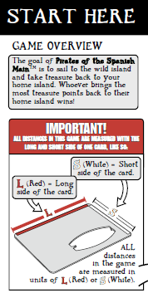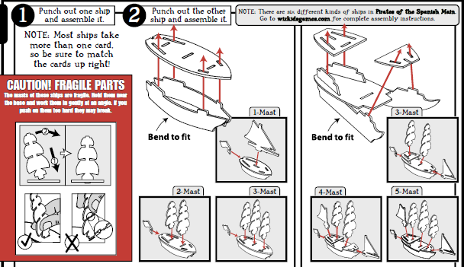
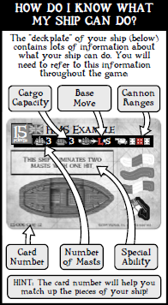
Rules of the High Seas
Here are some game concepts important to the Pirates of the Cursed Seas rules:
• Six-sided dice are abbreviated “d6.”
• Ability text (found on the fronts of cards) overrules these rules; that is, abilities are meant to be exceptions to these rules. The only rule that is never overruled is that a cannon die roll result of 1 always misses.
• Flavor text (fiction found on the backs of cards) has no bearing on game play; it is there merely to tell part of the game's story. Reference a card's ability text to see what it can do in the game.
• Two sources of the same ability text on a ship (such as from the ship and a crew, or from one crew and another crew) are not cumulative; that is, you can use that ability on that ship only once each turn. (No Stacking rule)
• The bow of a ship is a zone at the front of the ship. It begins where the front of the ship actually touches the table and extends forward (including any masts, mastheads, etc.).
• You can't give a ship (or other game pieces that can be given actions, such as sea creatures) more than two non-free actions each turn.
• Play with good sportsmanship and have fun!

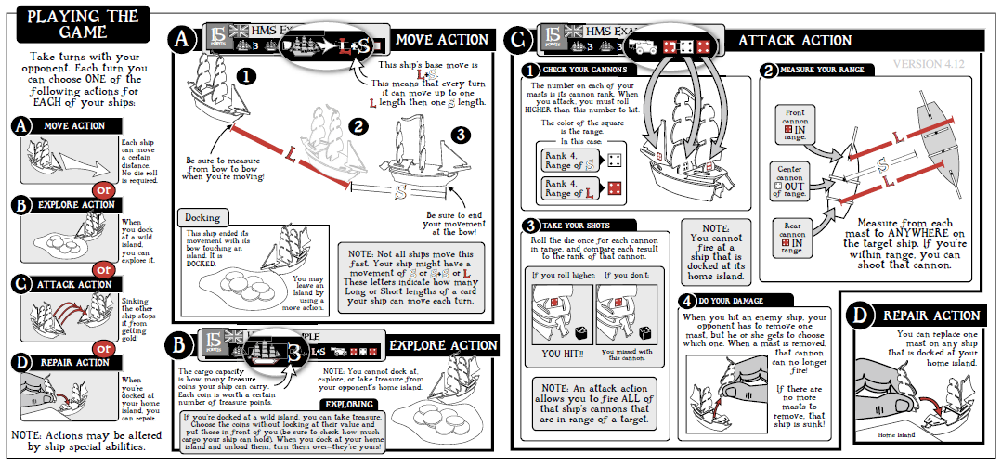
Shoot
Shoot

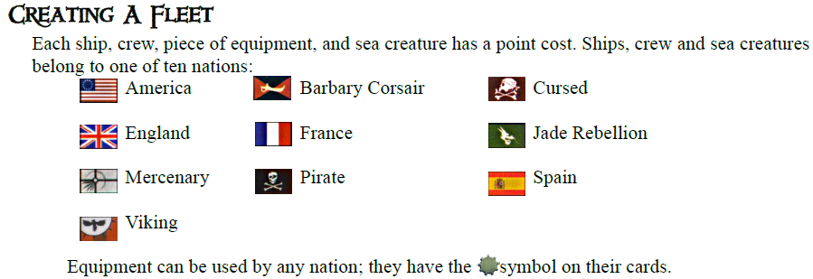
Fleets
To create a fleet, determine the build total at which you will play your game. We recommend a game with a 40-point build total; that is, choose ships, crew, equipment, and sea creatures (crew, equipment, and sea creatures are optional) with a combined point cost up to 40 points. Any build total can be chosen as long as both fleets use the same total. If a ship comes with a flag, she must fly it from her stern (rear of the ship). Players can build mixed-nationality fleets. The number of treasures and the total value contributed by each player should be decided before constructing fleets, if possible. The identities and complete statistics (including abilities) of all ships and forts in play are considered open information and must remain accessible to all other players during the course of the game.
-Creating your fleet occurs before the setup phase of a game. This is significant for the timing of certain abilities.
The No-Duplicates Rule: A player cannot have two or more of the same character, ship, sea creature, event token, or fort in their fleet at the same time unless it is captured from an opposing player. Generic crew and equipment are not limited in this way.
Setup
The game can be played on any tabletop or other flat surface. Each player rolls a d6 (reroll ties). The player who rolls the highest result is the first player; followed by the next highest-rolling player, and so on. (OR the player to the left of the first player is the second player. The order of remaining players is determined by continuing left around the table.)
-The maximum extents of the playing area (as designated by the edge of a table and/or a clearly marked perimeter) are considered an impassable wall that prevents all movement beyond. Alternative options include but are not limited to:
--Flat Earth: Any game piece that moves over the edge is permanently removed from the game.
--Round Earth: Any game piece that moves over an edge is immediately placed on the opposite edge of the playing area at the same heading and may continue with any remaining movement segments.
Placing Islands
For a 40-point game, players can use three islands per player (ex: six islands for two players, nine islands for three players, etc.). If you don't have enough islands, use similarly sized and shaped objects to represent them. Starting with the first player, players take turns randomly choosing an island and placing it on the play area. Islands are recommended to be placed at least 1L but not more than 6L from each other.
Mysterious Islands. Mysterious islands are special islands that have the symbol on them. They are placed as regular islands and have game text on them that might have special effects during the game. You can also choose to play them as regular islands with no special effects. Mysterious islands are always placed so that the symbol is face up; you might not be able to see the game text on some islands when you do this, but that's okay.
Placing Terrain
Terrain is printed on the backs of islands. Using terrain is optional. If you use terrain, players should agree on the number of terrain pieces that will be used; we recommend that players place the same number of terrain pieces, in the same order that they placed islands. Terrain can be placed anywhere on the play area, and each piece can touch any other piece of terrain. See “Terrain” for details.
Choosing Home Islands
The last player chooses which island will be the home island of the first player. The first player places his or her ships so that their bows (fronts of the ships) touch that island. The first player then chooses a different island to be the second player's home island, and that player places his or her ships so that their bows touch that island. The remaining player's home islands are chosen in order in this manner. The remaining islands are called wild islands. (OR the last player can choose their home island first, followed by the second to last player, and so on until the first player is the last to choose their home island.)
Mysterious islands. Mysterious islands chosen as home islands might show game text when placed with the face up. Before starting your game, choose whether or not you want to use that island's special effects. Mysterious islands that don't show game text when placed with the face up function only as home islands when chosen as home islands. They are not flipped over to reveal their special effects when ships dock at them (see “Docking”).
Placing Crew and equipment
If you have chosen crew and/or equipment, put them face down either on your home island or on the deckplate card of the ship to which you assign them. Each crew/equipment takes up one cargo space on a ship. No matter what a ship's cargo capacity, it can't carry crew and equipment with a combined point cost more than the ship's point cost. If a crew and ship are not of the same nationality, that crew can't use its ability while on that ship. A crew with a point cost of 0 can be assigned only to a ship that shares its nationality. You must reveal (turn face up) a crew when using its ability, and it must remain face up the remainder of the game. Crew and equipment can use their abilities only on ships, never on islands. Crew and equipment left on wild islands can be loaded by any ship.
Linked crew and ships. Some crew are “linked” to other crew and ships (as noted by the symbol printed on their cards). When two linked crew are assigned to the same ship, that ship gets +1 cargo space. In the same way, if one crew is assigned to a ship to which it is linked, that ship gets +1 cargo space. Multiple links on the same ship are cumulative; that is, a ship gains +1 cargo spaces each time two linked crew are assigned to her, or a crew linked to her is assigned to her.

Placing Treasure
Each treasure coin is printed with a number indicating how much gold it is worth. For a 40-point game, each player should contribute an equal amount of coins of any value or type (OR specified criteria such as 8 coins worth 15 gold). Shuffle the treasure with the numbers face down, and then randomly distribute an equal number of coins to each wild island.
Unique treasure. Some treasure is unique. A player can't contribute more than one unique treasure with the same name to the total treasure contributed to the game. At the beginning of the game, each unique treasure is worth 0 gold. A unique treasure's value may change later in the game, depending on its ability text. Players can insert unique treasure into the treasure that is randomly sorted and placed on wild islands.

Actions
The first player takes the first turn and is able to give one of four actions (move, explore, shoot, or repair) to each of his or her ships (or other game pieces that can be given actions, such as sea creatures). You can give actions only to ships in your fleet.
Free action. Unless a game effect specifically requires one of the four actions, that effect is a free action. Free actions happen automatically and immediately. A free action does not count as a ship's action for the turn on which it occurs.
Multiple actions. Some game effects allow you to give a ship a second action during a turn. You can't give a ship (or other game pieces that can be given actions, such as sea creatures) more than two non-free actions each turn.
-You may measure anything at any time, as long as it does not significantly delay the game.
Moving
A ship can't move through any island or another ship. If a ship has a combination move, such as L+S, you can choose to move her either L or S first, though she can change direction only between each measurement. If a ship touches another ship or an island during her movement, she must stop, even if she could move farther that turn.
Derelict. A ship is derelict if she has no masts. A derelict can't move and can be given only explore actions or repair actions. A derelict can still carry treasure and crew. Some abilities will prevent a ship from being considered derelict even if it has no masts remaining.
The following game functions can be performed using a move action or as the result of a move action.
Docking
As a free action, a ship docked at (touching) an island or a fort can drop off and board crew or equipment, or transfer crew or equipment to and from another ship docked at the same island. You can't dock at an opponent's home island or at an enemy fort.
Unloading treasure. When you dock at your home island or a fort, you must unload all treasure worth gold points; this is a free action. Treasure unloaded at a fort is placed inside of the fort, and it counts toward victory. See “Winning the Game.”
Mysterious islands. When you dock at a mysterious island, before any other action is taken (including any free explore action), roll a d6 for special effects as indicated by the table on the island. The rolled effect occurs immediately unless specified otherwise; for example, “The next time this ship explores this island . . . .” Mysterious island effects are determined each time a ship docks there, so a ship might have different experiences on the same island. If you can't fulfill a mysterious island effect, ignore it. If you dock at a mysterious island with no special effects showing, immediately flip it over to reveal the effects and proceed as described above. The island remains flipped over the rest of the game.
Ram
After a ship with at least one mast resolves a move action, if any part of her bow physically touches any part of an enemy ship, she rams that ship. The ramming ship automatically becomes pinned. Ships can't ram each other while they are pinned.
Pin. Unless an ability states otherwise, a ship becomes pinned only after ramming another ship. A ship is pinned when her bow is in contact with any part of an enemy ship. The pinned ship can't move until the other ship moves away or has no masts remaining.
Board. After a ship rams another ship, either player can initiate one (and only one) boarding party as a free action; the player whose turn it is decides first. Each player rolls a d6 and adds the result to the number of masts remaining on his or her ship involved in the ram. The player with the highest total can eliminate one crew on, or take one treasure from, the other ship. The loser of the boarding party chooses which crew to eliminate, while the winner chooses which treasure to take after looking at the ship’s treasure.
Tow
After a ship is given a move action, if any part of her is physically touching the bow of any derelict, she can tow that derelict as a free action. As a free action, move the derelict so that her bow touches the stern of the towing ship. The towed ship and any crew or treasure on that ship become part of the towing player's fleet. The base move of the towing ship becomes S; the towed ship moves with the towing ship as a free action. When the towing ship docks, dock the towed ship at the same island or fort as a free action.
Exploring
If a ship begins one of your turns docked at a wild island, give her an explore action to look at all the treasure on that island (without revealing it to the other players) and choose as much treasure as you want to take (within the ship's cargo capacity limits). Place each chosen treasure face down on the ship's deckplate card. Any treasure not taken is left face down on the island. When you leave a wild island, mark that you have explored it by leaving a token (such as a pennant flag) on the island; if you dock at an island with your token on it, you can explore it as a free action after docking. You can also explore any allied ship or derelict that your ship touches, which allows you to transfer crew and treasure between ships while at sea.
A unique treasure does not take up a cargo space unless an ability says otherwise. A unique treasure must be taken by the first player to explore the island on which it is placed. Place it face up on the ship's deckplate card; any ability a face-up unique treasure has comes into play immediately (as a free action).
Shooting
When a cannon shoots, draw an invisible “line of fire” from the printed die on the mast to any part of the target. If this line crosses one of your own ship's masts or sails, an island, or ships other than the target the line is being drawn to, the shot can't be made. You can't shoot at ships docked at their home islands, and you can't shoot at a ship in your own fleet. A die roll result of 1 automatically misses.
Sinking a ship. If a ship with no masts is hit, she sinks. When a ship sinks, remove her and any crew, equipment, and treasure on her from the game. Unique treasure is removed from the game when it sinks.
Scuttling. Sometimes you may want to sink your own ship rather than have her fall to your opponent. At any time during your turn, you can give one of your derelict ships a free action and declare that you plan to scuttle that ship. Roll a d6. On a result of 5 or 6, that derelict ship sinks at the beginning of your next turn. If an opponent begins to tow that ship before the beginning of your next turn, the scuttle attempt fails. All crew, equipment, and treasure on a scuttled ship are eliminated when she sinks.
Repairing
The repair action allows a ship docked at her home island or fort to repair (bring back into play) one mast.

Keywords
A keyword represents an ability a card has. If a card has a keyword, it appears in bold on the front of the card. When playing that card, follow the rules of that keyword in addition to any other ability text the card might have. If a keyword or an ability doesn't specifically say that a game piece can't do something, then it can do it. (For explanations of specific keywords, see Pirates Master Keyword List)
Forts
Forts are printed on two cards and are assembled like ships. Fort flags represent cannons, and you can customize a fort by placing flags on either its corners or walls. Forts are not placed during setup; rather, they are purchased and built during the game on wild islands you have explored. A wild island may have only one fort on it at a time.
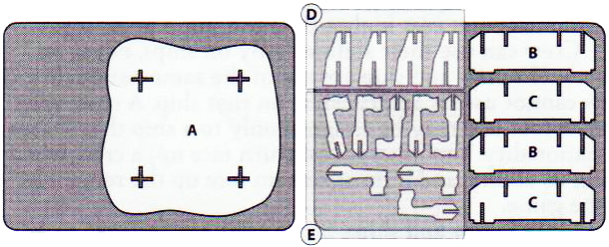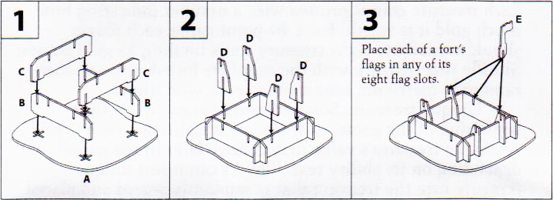
Building Forts
To build a fort, the following three conditions must be met:
-You must have the fort in your Pirates collection.
-You must have an amount of gold points on your home island equal to or greater than the fort's gold point cost.
-You must have a ship docked at a wild island you have explored in order to build a fort there.
If these three prerequisites are met at the end of one of your turns, you may build the fort as a free action. Take the gold used to pay for it from your home island and place it inside of the assembled fort; this gold still counts toward winning the game. Place the assembled fort on any wild island at which you have a ship docked. The fort must be placed on the island such that two of its opposite corners are completely on the island. The effects of a mysterious island are ignored if a fort is present on the island.
Treasure. If there is any face-down treasure on the island where the fort is built, move that treasure inside of the assembled fort; it is now yours. You may use a ship to load treasure from a fort and move it to another fort or to your home island, but a fort must always have a number of gold points inside of it equal to or greater than its gold point cost.
Shooting. Forts may be given only shoot actions. Shooting with fort cannons is just like shooting with ship cannons; use the indicated ranges and ranks on the flags and measure distance from the flags. Lines of fire drawn from forts are not blocked by other ships, sea creatures, or islands.
Abandoned forts. When a fort is hit, its player eliminates a flag. When all of a fort's flags are eliminated, it is abandoned and may not be given actions.
Destroying forts. If an abandoned fort is hit, remove it from the game and place all of the gold that was inside of it back on the island, which reverts to an unexplored wild island.

Terrain
Terrain is printed on the backs of island cards. You may choose to use the terrain side (per the rules for that terrain, below) or the island side (per the normal rules for islands). If any part of a ship touches terrain at the end of any movement segment the effects of that terrain must be applied immediately. If the ship has not become derelict, wrecked, tangled, or “lost”, and has not been placed at another whirlpool, it may then continue with any remaining movement segments. The effect of a given terrain piece is applied only once per move action, regardless of the number of segments that may end on or in contact with it.
Fog Bank
A fog bank has the numbers 1-6 printed around its edge. Fog banks block lines of fire. When any part of a ship or sea creature touches a fog bank, the entire game piece must be placed within the fog bank as a free action; the game piece's turn ends, even if it could move farther that turn. A game piece in a fog bank is lost. Lost game pieces can't shoot, be shot at, ram or be rammed, pin or be pinned, or board or be boarded by other ships. Game pieces exit fog banks in random directions. When a game piece is given a move action to exit a fog bank, roll one d6 before moving it. Place the game piece outside of the fog bank facing away from the fog bank and touching the number on the fog bank that matches the die result; it can face in any direction away from the fog bank and is no longer lost. Begin moving the game piece from that point.
Iceberg
An iceberg has the numbers 1-6 printed around its edge, as well as a gold number printed at its center. At the beginning of each player's turn, before any actions are assigned, that player must roll a d6. Compare the result to the gold number printed on all icebergs in play. If the result matches any iceberg(s), those icebergs move that turn. For each iceberg that will move, roll another d6 and match the result to the number printed around the iceberg's edge. Measuring straight out from that number away from the iceberg, move the iceberg S. Do not turn or rotate it. If an iceberg touches any ship or sea creature, stop moving it and eliminate one mast or segment from the touched ship or sea creature. If an iceberg hits an island, it can no longer move the rest of the game.
Reef
When any part of a ship or sea creature moves onto a reef, roll a d6. The result is the reef's rating until the end of that player's turn. Place the die result on the reef to remind you what the rating is. Compare the rating to how many masts or segments the game piece had when it was constructed. If the reef's rating is lower than this number of masts or segments, the game piece has a number of masts or segments eliminated equal to the difference. For example, if a 3-mast ship sails over a reef with a rating of 4, no masts are eliminated. If a 4-mast ship sails over a reef with a rating of 2, two masts are eliminated. If the reef rating and number of masts or segments are the same, no masts or segments are eliminated. A game piece that begins its turn on a reef does not have to roll to see if masts or segments are eliminated when it moves off of the reef.
Shipwreck. If a ship takes more damage than the number of masts remaining as a result of sailing over a reef, she is wrecked and remains on the reef; a wreck blocks movement and lines of fire. To signify that a ship is a wreck, remove one of her hull pieces. This will cause the ship to “lean” onto the reef and look like she is wrecked there. Any crew or treasure on a wreck remains on the wreck, and wrecks can be explored. Sea creatures that have all their segments eliminated by a reef are eliminated as normal.
Sargasso Sea
When a ship or sea creature moves over a Sargasso Sea, roll a d6. The result is the Sargasso Sea's rating until the end of that player's turn. Compare the rating to how many masts or segments the game piece had when it was constructed. If the Sargasso Sea's rating is more than the number of masts or segments, the game piece is tangled in the weeds and might not be able to move. For example, if a 3-mast ship sails over a Sargasso Sea with a rating of 4, she is tangled. If a 4- mast ship sails over a Sargasso Sea with a rating of 2, the ship is unaffected. If the Sargasso Sea rating and the number of masts or segments are the same, the game piece is unaffected. If a game piece is tangled, you can use its action for the turn to try to free it. Roll a d6 and add the current number of masts or segments on the tangled game piece to the result. If the result is more than 6, the game piece is untangled. Orient it in any direction, facing away from the Sargasso Sea and touching any edge of the Sargasso Sea. It can be given a move action to move normally next turn.
Trade Current
A trade current is a type of terrain not placed at the beginning of the game. Instead, game effects allow trade currents to be placed during the game. For example, crew with the Navigator keyword can place trade currents. A trade current is friendly to the player who placed it. Once per turn when a friendly ship moves over or begins her turn touching a friendly trade current, she gets +S to her base move.
Whirlpool
When any part of your ship or sea creature touches a whirlpool, you may choose to place it so that it touches any other whirlpool on the play area. If you do, roll a d6 after it is moved. On a result of 1-3, eliminate either one mast or segment, one treasure, or one crew from the game piece. The use of a whirlpool’s effect is optional. If it is not used, no die roll is required. In order to “use” a whirlpool, the ship must be placed at a different whirlpool. A ship cannot exit the same whirlpool that it entered simply to dispose of unwanted cargo. Whirlpools only eliminate masts, treasure, and crew. They will not eliminate equipment or sink ships. Using a whirlpool to jump to another whirlpool ends the ship’s entire move action. It cannot shoot (via a Captain), ram, board, or use any other effects that require a move action, until it is given another move action after exiting the second whirlpool.

Winning the Game
The game ends immediately when one of the following conditions has been met:
-All available gold has been unloaded to home islands.
-Only one player is able to give any future move actions to any of their ships (OR half or more players have no possibility of giving any future move actions to any of their ships.)

When any endgame condition is reached, players add up the total gold value of all treasure on their home islands and in their forts. Treasure on a ship that is wrecked or lost in a fog bank does not count for any player. The player with the highest gold value wins. If there is a tie, mutually agreed upon tiebreakers include gold on remaining ships, total masts standing, or most remaining points in play. (OR the player with the most remaining units in play is the winner. A “unit” is defined as any game piece that can be directly given at least one of the four primary actions (move, shoot, repair, or explore). This includes ships, sea creatures, flotillas, forts, and crew with the Marine keyword, but does not include events, equipment, treasure, or non-Marine crew.)
-If a player completely eliminates an opposing player’s fleet they do not automatically win and do not automatically get any uncollected gold remaining in play.

Sea Creatures
Sea creatures are game pieces that act like ships in the game. Each sea creature has a keyword, however, that describes the ways that creature is different from ships (see “Keywords”). Sea creatures have segments (tentacles, coils, wings, etc.) that act like masts in the game (for purposes of shooting and taking damage). When a sea creature has no segments, it is eliminated. Sea creatures can't be rammed, pinned, or boarded. Nor can they ram, load treasure, tow, or be assigned crew. Sea creatures can be given only move and shoot actions. Sea creatures begin the game with any part of their base touching your home island. Measure a sea creature's movement from anywhere on its base. A sea creature's segments do not block its line of fire when shooting (see “Shooting”).
-Any game piece with the Sea Dragon, Sea Monster, Titan, Kraken, or Octopus keyword printed on its deckplate card is considered a sea creature, even if the effect of that keyword has been cancelled.
-Sea creatures are considered to be ships. Any actions, abilities, or other effects that refer to ships can be applied.

